Milestone Three

Visualization

Michael Surdek
Southern New Hampshire University
DAT 610: Optimization & Risk Assessment
Professor Kyle Camac
November 14, 2021
With increasing standards and regulations as well as technological capabilities, operational risk event data is being collected and analyzed more than ever before. One common analysis method is data visualization. Data visualization is the process of communicating information to an audience in an easily digestible way. “Graphs and charts let you explore and learn about the structure of the information you collect. Good data visualizations also make it easier to communicate your ideas and findings to other people.” (Healy, 2019) Data of all kinds can be represented through visual properties such as length, size, position, shape and color. Effective data visualization often includes the highlighting of key elements or the labeling of items of interest. Additionally, data visualization supports the analytical process because it can cover either the original dataset or elements from statistical models that have been developed.
As an organization’s risk management framework matures, the need for visualization of operational risk event data grows. Data visualization can support various forms of risk-related communication such as weekly committee meetings, daily reports, and day-to-day analysis. For this reason, the data visualization process evolves from its initial stage through repeatable, defined, and managed stages before reaching the optimization stage, as shown in the figure below. (Protiviti, 2006) The responsibilities of a data visualization practicioner also change as the process evolves. At first, they might undertake one-off requests from risk managers. They will be developing an understanding of the available data and producing the analysis that seems most important in the early stages. This will often include risk identification, which is a critical aspect of risk management. “Graphic representations of risks...help to prevent that one focuses only on the most pressing problems.” (Eppler, 2009) Eventually, pipelines for the data and basic analysis are established and visualization efforts can be directed towards statistical analysis and continuous feedback.
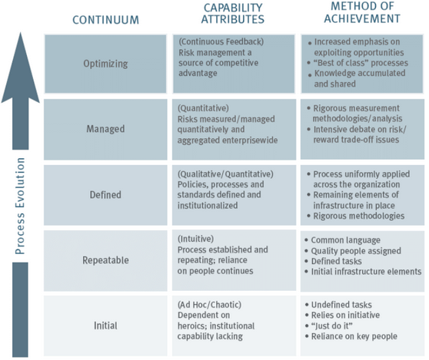
There are various tools and techniques that best serve an organization’s objectives as each stage in the process. These tools allow data visualization practicioners to create charts and graphs and to even embed them into reports or interactive dashboards. In the early stages, point and click software systems such as Tableau, Spotfire, and Power BI are effective tools for ad-hoc and repeatable anlaysis requests. They can connect to sources of data whether they are stored in flat files or in enterprise databases and they provide a simple user interface to customize the analysis. In later stages, most organizations will turn to code-based visualization tools. These tools include the matplotlib and ggplot2 libraries for creating visualizations in python and R, respectively. They can also be easily integrated with report and dashboard developing packages such as rmarkdown, r shiny, and python dash. Finally, if an organization prefers to use a pre-packaged data visualization tool, most enterprise risk management software products, such as Sword Active Risk Manager, offer visualization methods that are tailored to risk analysis.
Data visualization can certainly support Company XYZ’s programs, policies, and strategies for risk management. Between the corporate operational risk function that they are establishing and their objective of enhancing the Special Investigation Unit, data visualization will play a key role in communicating important risk information. Even in the initial stages, there are many ways Company XYZ can leverage data visualization through their internal claims file and additional information that they can gather from external sources. For example, they could plot the amounts claimed v the amounts paid for each claim and they could include the claim suspicion score to see if there is any relationship between the likelihood of fraud and whether or not it is improving their abilities to investigate and resolve suspicious claims.
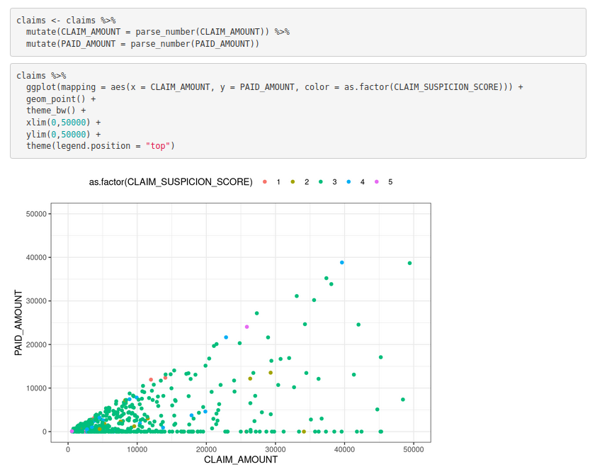
References:

Eppler, Martin & Aeschimann, Markus. (2009). A systematic framework for risk visualization in risk management and communication. Università della Svizzera italiana. Retrieved from
https://www.researchgate.net/publication/228533068_A_systematic_framework_for_risk_
visualization_in_risk_management_and_communication

Healy, Kieran. (2019). Data Visualization: A Practical Introduction. Princeton University Press.

Protiviti. (2006). Guide to Enterprise Risk Management. Protiviti Insights. Retrieved from https://www.protiviti.com/US-en/insights/guide-enterprise-risk-management

